Press Release Template
(On organization letterhead)
FOR IMMEDIATE RELEASE: CONTACT:
[Date] Name
Phone
Email address
[Insert Agency] Celebrates Home Care and Hospice Month in November

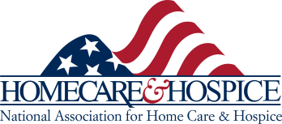
City (Date) – During November the home care and hospice community honors the millions of nurses, home care aides, therapists, and social workers who make a remarkable difference for the patients and families they serve. These heroic caregivers play a central role in our health care system and in homes across the nation. To recognize their efforts, we call upon all Americans to commemorate the power of caring, both at the home and in their local communities and join with [INSERT AGENCY NAME] and the National Association for Home
Care & Hospice (NAHC) by celebrating November as National Home Care &Hospice
Month.

With 10 thousand Americans turning 65 every day, the need for health care will continue to rise, and costs will continue to skyrocket. This is where home care and hospice come in. As the preferred choice for most patients, it also offers the greatest cost savings. For example, Medicare pays nearly $2,000 per day for a typical hospital stay and $450 per day for a typical nursing home stay. Meanwhile, home care costs less than $100 a day and helps many U.S. seniors remain independent at home, enrich their lives, and keep in touch with those they love.
NOVEMBER

[INSERT AGENCY QUOTE]

For more information about the National Association for Home Care &
Hospice, Home Care & Hospice Month, and Home Care Aide Week, visit nahc.org/homecare-hospice-month.

About [Insert Agency Name] [boilerplate for Agency]

* * * *

